VALUED LIVING (Adapted from Steven C Hayes https://stevenchayes.com/)
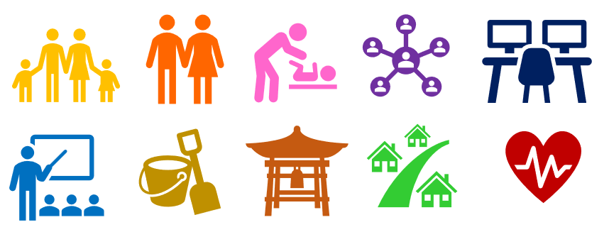
Values are guiding principles that lead and motivate us through life. Values are directions we keep moving in and different from goals, which are specific things we want to achieve along the way. For example, a value is if you want to be in a relationship where you and your partner are loving and supportive to each other. If you or your partner stop being loving and supportive, then you are not living by that value. If you want to run a marathon, that is a goal not a value as it can be ‘crossed off’ once achieved.

The following domains are typical areas of life that are often valued by people. Everyone is different, so there are no ‘correct’ values. This exercise is to help you think about what is important to you in your life in terms of general direction rather than goals. Deep down, what is important to you? What do you want your life to stand for? What sort of qualities do you want to cultivate as a person?

Domains
1. Family - What sort of family relations would you like to have? What personal qualities would you like to bring to those relationships? What sort of relationships would you like to build? How would the relationships be if they were ideal?
2. Couple - What sort of intimate relationship would you like to have? How would you interact with your partner if you were the ‘ideal you’ in this relationship and how would they ideally interact with you?
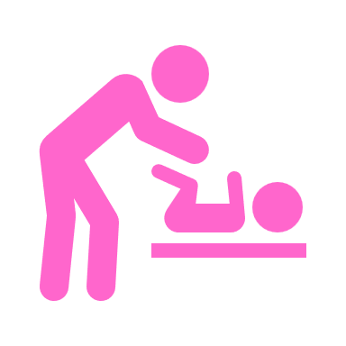
3. Parenting - What sort of parent would you like to be? What sort of qualities would you like to have? What sort of relationships would you like to build with your children? How would you behave if you were the ‘ideal you’?
4. Friendships/Social Life - What sort of qualities would you like to bring to your friendships? What sort of friendships would you like to build? How would you like your social life to be?
5. Employment/Career - What do you value in your work? What would make work more meaningful? What kind of worker would you like to be? What sort of work relations would you like to build?
6. Education/ Training - What do you value about learning, training, or personal growth? What new skills would you like to learn? What knowledge would you like to gain?
7. Recreation/ Leisure - What sorts of hobbies, sports, or leisure activities do you enjoy? How do you relax and unwind? How do you have fun?
8. Spirituality - Whatever spirituality means to you is fine. It may be communing with nature, or participation in an organised religious group. How do you express yourself spiritually.
9. Citizenship/ Community - How would you like to contribute to your community, for example, volunteering, recycling, supporting a charity or a political party?
10. Health/ Wellbeing - What are your values related to maintaining your physical and general well-being? How do you look after yourself in relation to sleep, diet, exercise, relaxation etc?

Instructions - Completing the Domain Table Inventory:

1. Read through the information on the different domains on the pages 1 and 2.
2. Write a few words to summarise your values in each domain in the table below. For example, in the Family domain you may write “loving, harmonious, fun”.
3. Rate the Importance of each Domain to you on a scale of 0 to 10 (you do not have to rank them against each other).
4. Rate the Success (on average) you feel you have in living in accordance with your values from 0 to 10 in each Domain.

Domain | Brief summary of how you would live this value? | Importance low 0-10 high | Success  low 0-10 high
1. Family | Shared childhood, sense of home, support network, talking to each other, shared values. | 8 | 5
2. Couple

3. Parenting

4. Friendships/ Social Life

5. Employment/
Career
6. Education/ Training

7. Recreation/ Leisure

8. Spirituality

9. Citizenship/ Community

10. Health/ Wellbeing

OVERALL BALANCE
Parenting
Family
Couple
Other
Friends
Community
Spirituality
Leisure
Education
Career
Health
Other

Lifestyle Balance

In order to begin combating negative emotional states, it is necessary to evaluate how you are spending your time each day and the balance of your lifestyle overall. Here is a list of the typical elements that need to be included in your daily/weekly routine to achieve a balanced lifestyle. The circle on the preceding page is for you to fill in to self-assess how balanced your lifestyle is and what you may benefit from incorporating more of in your daily/weekly routines.

Sleep - Sleep is incredibly important for emotional wellbeing. See a more detailed good sleep guide at the end of this document.

Nutrition – The food we eat for fuel is highly significant in the quality of energy we will get out of it. For healthy brain and body function and to feel good we need fresh fruit, vegetables and protein, with limited intake of sugar/carbohydrates, processed foods, chemical additives, convenience foods and junk food.

Fluid intake - Make sure to drink enough fluid each day to avoid dehydration, replace some of drinks which have chemicals or caffeine with water so you don’t add to your body’s stress levels as it will have less to detox and you will feel fresher.

Chores – If you get behind with chores, doing a small task each day will result in increases to your self-esteem. Breaking bigger chores down in to small chunks helps motivation, for example, the whole house might need cleaning, set your task as just doing one room or half of one room.

Personal care - Taking care of yourself is very important, things like: taking a refreshing bath/shower, having a manicure or doing your nails yourself, shaving, getting a haircut, going to the dentist, cleaning shoes, using hand cream or moisturiser, wearing some makeup, whatever works for you. All things related so ‘self-care’ may increase your self-esteem and lower anxiety/stress levels.

Exercise - Some exercise should be taken most days, if you don’t like any sports or going to the gym or exercise classes, then taking a brisk 20 minute walk most days will help improve emotional wellbeing and your sleep.

Relaxing activity - Getting time ‘away from it all’ every now and then by reducing the amount of stimulation from the environment and other people, e.g. turn off computers, phones, TV, radio etc. Have a massage, meditate, listen to relaxing music, recline with a good book, go for a walk in the country side.

Pleasure activity - Enjoyable hobbies, if you can’t think of anything you enjoy doing, perhaps resurrect an old hobby you used to enjoy as a child or search the internet for information about a new hobby you could take up. Without having a number of leisure activities in life that we really enjoy, life will seem dull and may lead to depression.

Social activity - Try not spend too much time on your own. Isolation, even when by choice, may lead to low self-esteem, and possibly social anxiety and depression. Mixing with others with whom you have positive relationships will improve self-esteem and mood. If you feel you don’t have social contacts, or you already have some social anxiety, discuss this with your therapist who will be able to help you find a solution.

Mastery activity – Completing those essential tasks you don’t like doing, things you are tempted to put-off but that have to be done, e.g. paying bills, sorting out messy draws, making ‘that’ phone call etc. Doing mastery tasks, particularly at the start of the day to get them out of the way, leads to improved self-esteem and improved mood.
GOOD SLEEP GUIDE
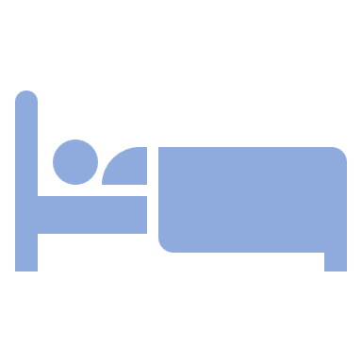
Sleep is as essential to us as food, air and water. Yet sometimes in our lives we may experience difficulty in sleeping (about one in three adults report some degree of insomnia at any one time). If you are having trouble sleeping, some changes in lifestyle could help you regain a satisfactory sleep pattern. As well as developing a balanced lifestyle, experiment with some of the following:

Half Hour Wind-Down

Half an hour before bedtime, start winding down. Stop doing anything that is too stimulating/interesting, turn off the TV and do something that is relaxing instead, e.g. read something “light”, listen to a podcast story or gentle music. A less cluttered and clean environment can be easier to sleep in. Some people find a routine of making sure their bedroom is clean and tidy before going to bed helps them get a good sleep.

Warm bath

Try taking a warm bath before going to bed. This will help relax and soothe your muscles. Showers tend to wake you up so try to avoid them before bedtime.

Let your thoughts go!

Keep a note pad and pencil by your bed so that if you think of something important or something worrying, you can jot it down … but then, let the thought go so you can get a night of restful sleep instead of staying awake thinking.

Room Temperature

Try to keep the temperature in your bedroom fairly cool, say 60 degrees or so. Use extra bedding if you get cold rather than turning up the heat. Keep a window open, if possible, to stop the air drying out in your bedroom. Overly dry air may cause coughs that can disturb sleep.

Eating

Try to eat your last big meal 4 hours before bedtime. If you eat too much too close to bedtime, your digestive system will still be actively digesting the food which may disturb your sleep. A warm, milky drink can aid sleep, e.g. Ovaltine, Horlicks etc, because milk has an essential amino acid, tryptophan, which is believed to play a role in inducing sleep. A small amount of wholewheat carbohydrate can enhance the effect, e.g. a slice of wholewheat bread.

Avoid chemical stimulants

Avoid caffeine for 6 hours at least before bedtime. Caffeine can be found in a number of different products, not just tea, coffee and coke drinks. Check packaging for ingredients of anything you consume in the hours leading up to bedtime. Bad news for smokers and chocolate-lovers, nicotine and chocolate are both stimulants and, like caffeine, can cause hyperactivity and wakefulness. Other foods that sleep laboratories have found can cause wakefulness or disturb sleep are cheddar cheese, ripe avocados, beer, fermented meats (pepperoni, salami), anything containing hot spices and red wine. Concerning alcohol, although it may appear to help induce ‘sleep’, it is poor quality, tends to be more shallow, can cause missed sleep stages and frequently leads to early morning waking, not to mention the hang-over that comes with even relatively small amounts of alcohol.

Alcohol

Alcohol should be avoided before bed as it interferes with stages of sleep. Too much alcohol at any time will have a negative impact on emotional wellbeing generally, not just sleep. The accepted safe limit for adults is 14 units of alcohol a week. One pub measure of spirits is 1 unit, one glass (175ml ) wine is 2 units and one pint of beer (ABV 3.6%) is 2 units. As alcoholic drinks vary in strength/volume, calculating your intake may require some maths (strength [ABV] x volume [ml] ÷ 1,000 = units) or you may be drinking more than you realise.

Noise

Some people seem to sleep better if they are not in complete silence. A podcast or music on quietly can help them relax enough to fall asleep. Others find this disturbing and prefer white noise, like a fan running in the background. If too much outside noise is a problem, you could try ear plugs (use safe ear plugs on sale in chemists or similar stores) and using recordings of white noise to help disguise/mask the outside noise.

Exercise

Taking regular exercise is an excellent way of improving your ability to sleep well and the importance of exercise to overall emotional well-being cannot be stressed enough. The more energy you use up during the day, i.e. the more active you are, the more your body will be ready for sleep at bedtime.

Relax

When you are in bed, you could try listening to relaxation, hypnotherapy or mindfulness tracks to play in the background to help you drift off to sleep. Or, you could follow guided mindful breathing or progressive muscle relaxation exercise to help you wind-down and get yourself ready for sleep.

No Napping during the Day

If you want to sleep well at night, try at all costs to avoid sleeping during the day. Day-time sleeps re-charge your batteries so you will not be ready for sleep at night. If you feel sleepy during the day, don’t sit down in a chair but get up and do something stimulating and/or invigorating to ‘wake yourself up’.

Early Waking
If you wake early, e.g. 4-5am, don’t try to force yourself to get back to sleep. Instead, get up and begin the day. If you feel rested, you’ve probably had enough sleep and will get a head start on other people. If you still feel tired, get up anyway and go through the day, avoiding naps, so you will be ready for sleep at bedtime.

Lying Awake

If you have been lying awake and can’t sleep for some time, get out of bed completely, sit in a chair in a different room and read, write a letter or do some other quiet activity. As you get sleepy, go back to bed and use a relaxation, hypnotherapy or mindfulness CD or other relaxation technique to fall asleep. Make your bedroom a place to sleep, not a place to get other things done.

How much sleep do you need?

Everyone is different and it varies widely and we are sometimes also not very good at judging how much sleep we get or need. The amount of sleep you need will vary depending on how much physical and emotional energy you have used up during the day. We tend to need more sleep and experience more sleeplessness if we are stressed or distressed in some way, this includes suffering from mental health problems. Most people can function reasonably well on 5 or 6 hours of sleep, some people don’t need this much and some need more. If you feel you are not getting enough or sleeping too much, implementing the ideas in this sleep guide should help you.

